Blog Post: New 9x12 Calendar + Calendar Designs
Job: USM11612
Date: 10/27/16
Version: 4
Writer: Alison Messinger

Easy Gifting for Everyone on Your List: Check Out What’s New in Calendars

By Alison Messinger

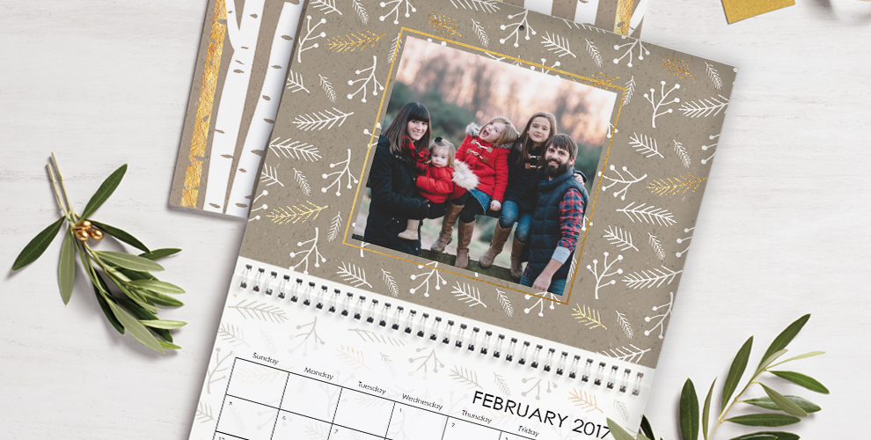
We love ordering calendars this time of year. We usually make quite a few: one for the office, two for home, five more for family members (they make great gifts, too!) Whether you’re a seasoned calendar maker, or creating one for the first time, read on to learn about the amazing calendars we have in store!
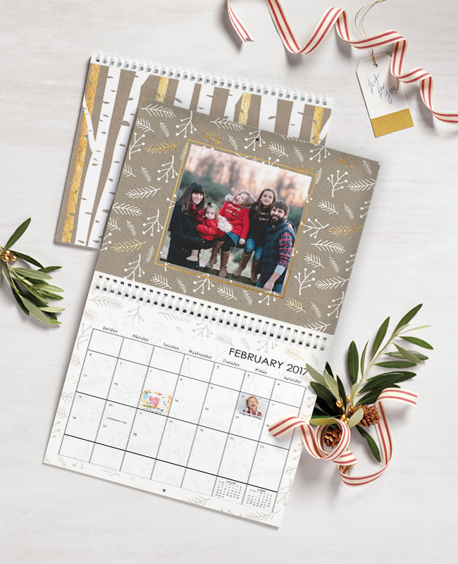
Snapfish calendars are a fun and unique way to share photos and keep track of important dates. Mark birthdays, anniversaries, and other special dates with personalized photos and text right on the calendar grid. The calendar pages are printed on high-quality paper to make your photos come alive. (Little-known fact: you can also choose which month you want your calendar to start on!)
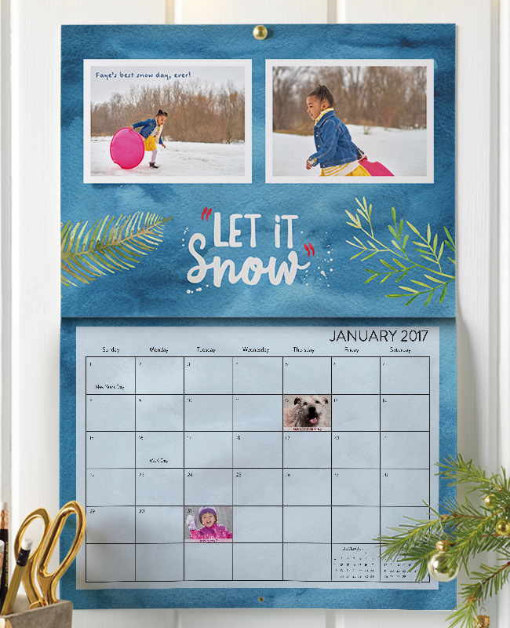
We’re also excited to introduce a new calendar for this holiday season—our 9x12 Premium Wall Calendar! Printed on a rich matte cardstock, this calendar soaks up color so your photos and designs really pop. (check out our new watercolor-inspired designs below). We’ve also swapped out the spiral coil for seamless binding to give it a more modern look, so you’re not just getting a calendar, you’re getting a piece of art. Why not put one in every room?

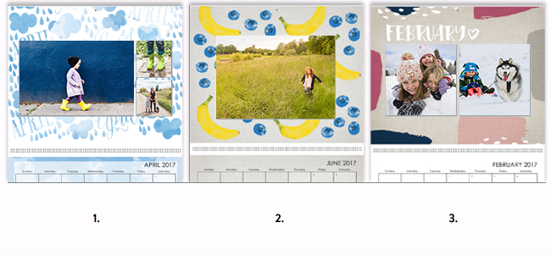
Check out a few of our favorite new designs!
Designs from left to right: Seasonal Watercolor >, Farm to Wall >, Playful Patterns >.

We love seeing what you create! Fill up your santa bag and share all the photo fun on Instagram with #snapfish.

